1. 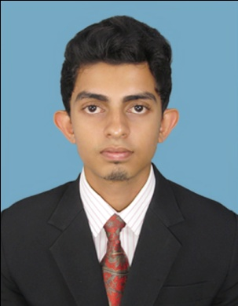Harshana Naleen Rupasinghe

Address - Harsha paya, jayakaduwa, Ku/Pusselithenna.

E- Mail - nalin075@gmail.com

Contact - 071-7153814 / 037-5715991

Objective

With the knowledge and skills, I have acquired, my ambition is to work in a reputed organization where I could further enhance my creativity, knowledge and skills while sharing my knowledge productivity with my employer.

Educational Qualification

School Education **G. C. E. (Ordinary Level) Examination (Sinhala Medium) in 2010**

**School attended : Sir Jhon Kothalawala Maha Vidyalaya Kurunagala.**

Buddhism A

Mathematics A

History B

Health & Physical Education A

Geography A

Sinhala C

Sciences & Technology C

Art S

English S

**G. C. E. (Advanced Level) Examination in 2013**

**School attended : Sir Jhon Kothalawala Maha Vidyalaya Kurunagala**.

Accounting C

Business Studies C

Economics C

Other Qualification - I have completed HRM Diploma Course in Kandy.

* I have completed a Computer Course in Kurunegala.
* I have completed a English Course at British Way English Academy.
* I was prefect in Sri Jhon kothalawala Maha Vidyalaya Kurunegala.

**Sports**

* I was a member of school Cricket Team. (2years)
* Athletic - 100x4
  + - * 100m
      * 400x4

Working Experiences - I have 2 year working experiences in ASLIYA PRINTERS, Kurunegala.as a Assistant Accountant.

(accounting , Payroll , Stock Handling)

* I am member of Youth of Education Sri Lanka (SLNS.ORG)2004.

Personal Information

Full Name - A. Harshana Naleen Rupasinghe

Gender - Male

Date of Birth - 4th June 1994

Address - Harsha paya, Jayakaduwa, Ku/ Pusselithenna.

Age - 22 years

N. I. C. No. - 941563252 V

Religion - Buddhism

Civil Status - Unmarried

School Attended - Sir Jhon Kothalawala Maha Vidyalaya Kurunegala.

References

Ven. P. Gunannda Thero.

Malwathu Maha Viharawasi,

Jayakadulena Rajamaha Viharaya,

Pusselithenna,

Mawathagama.

037-2299996 / 071-8236825

Mr. Dinesh Dilanka wijewardana

Accountant,

Asliya printers,

No.259,Colombo Road,

Kurunegala,

078-3939570/037-2221772

I do hereby Certify that the above mentioned particulars true and accurate to the best of my knowledge.

---------------------- ----------------------------

Date Signature